Team Name: Bubble Blowers
Kaitlyn Osgood
Savion Morgan Cooper
Jonathan Serrano
Bubble Sort
May 2026

Advisor: Kasey Nguyen, PhD

Part I – Application Overview
Objectives

Our objective with our team was to develop a program that allows the user to input values and will generate an output that will sort the values in ascending order using the “Bubble Sort” technique. This program, while useful to many fields that require data analysis, aims to predominantly market to healthcare companies that require a fast output to increase productivity amongst staff. The private healthcare industry in the United States generates billions of dollars in revenue annually and as such are constantly looking for ways to reduce costs, replace old technology, and simplify computer programs to increase productivity which results in a higher number of patients seen in a day.

This project was conceived to assist our essential workers whilst simultaneously being a low cost alternative compared to pricier software that requires higher tech computers to run efficiently. We are opting to do this project now because in an era of complex programs that are not very user friendly, we are putting forth a product that aims to require no formal training to use by the employee and is a simple tool that can become as important as the calculator app on your smart phone.

While this is a simple concept program, we think this is an important program to create because we have yet to see a similar program for the sole intent of sorting values efficiently and effectively. If we do not create this program, we feel that down the line another company will come up with the idea for simplistic efficient software and profit, so it is imperative that we gain traction with this idea first.
Nowadays, healthcare workers are plagued by numerous software they are required to keep open that simply flood the memory of their computers and as a result their productivity slows from having to wait on their computer lagging. Whether it be pharmacists needing to quickly analyze the grams they input, the hospital billing department needing to visualize spending, or a nurse who wants to gauge the change in their patients blood pressure history; we are offering a low memory program that will increase productivity across all departments.

Business Process
As mentioned previously, we aim to market this program to the healthcare industry, and if we see success then branch out to other industries that require fast data analysis such as the hospitality industry. With the idea to market on the motto “Sometimes Simpler is Better”, we are not trying to outcompete any existing software, but rather to create a tool for daily use that is as easy to use as your smartphone calculator or any other simplistic software preinstalled to the existing computer.

Currently, within this market there are many data analysis software that allow a user to input data, but at the cost of requiring training to use said software and oftentimes slowing down the company computers. At large scale operations such as hospitals, it simply isn’t feasible for every clerk, nurse, technician to have a computer that has sizable RAM meant to run these software without hassle.

The value we hope to bring with this product is through simplicity and the fact that we are not trying to outcompete any large scale data analysis software currently in use by the company. Our decision to focus on one task and to do it well is what will set us apart from other software because we aim to program this software efficiently so the user isn’t left waiting for the results of their input.

User Roles and Responsibilities

Our program is intended to be used as a quick tool by all departments within a healthcare setting. The reach of this program is for quick on the spot data analysis and we intend for this program to fit into numerous aspects of different jobs.

If we want to hone in on the billing/finance department, quickbooks requires training to use and sometimes you don’t want to have to wait for a program when you just want to simply quickly analyze a small set of input values. When our application is introduced, it won’t be replacing quickbooks but rather would be a tool in the clerks toolbelt to quickly pull out and generate the organized list of values. When a patient asks for an itemized bill of receipt, this is usually created outside of the current billing software and has to be manually created by the assisting clerk. To increase readability on an itemized receipt, it is preferable to sort the values in increasing order so the patient can easily understand the charges being made. To the clerk creating this list, it would be preferable to have a tool that will quickly organize their input without requiring much more information.

Our intent for help with nurses is so they can quickly see a trend in their input values to assist with patient questions and better organize patient history. When a patient has a question about their test result history, we understand that sometimes it may be hard to look through a large medical history and quickly analyze how these values compare. With this tool, they can simply input glucose levels or temperature readings to get a quick visualization on the trends present in those values.

We also aim for this product to have usability in the pharmacology department of the hospital. Whilst measuring drugs and other prescriptions, it is standard practice to keep track of weights, inventory, etc. While staring at values all day, it is easy for one to make mistakes and falsely think a value is larger or smaller than the other.

There are many instances where this program can be useful to employees and within a hospital there are many instances when data needs to be analyzed quickly and without delay.

Production Rollout Considerations

We plan to roll out the product in phases to prepare for updates and gauge user feedback to ensure the product is satisfactory for a launch date.

We plan to have two trial phases before launch, with the initial phase launching the application as is to gain user feedback. During this phase we will work with a select number of hospitals that have agreed to trial run the beta version of the application. During this period we will take note of any and all bugs to amend for final launch. Additionally, all user feedback will be taken into consideration to ensure that our product will be desired by the clientele.

Our second phase will include a major update that seeks to fix major bugs that can occur and possibly tweak to accommodate user feedback. This phase is integral to rollout as it ensures our customer support team is working directly with the development team to ensure that bugs are getting appropriately addressed and user feedback is being listened to. We wish for this product to be the best version it can be for our clientele whilst maintaining our minimalist ideal of accomplishing small tasks in an isolated application free from clutter.

On launch, we plan the best version of our program available for purchase. Since we wanted to isolate a specific market, we expect the initial transaction volume to be small in order to deal with any issues our program may have at launch. We want to account for our small team dealing with system logs that will document any crash reports or any possible mishaps with the application. Our development team will be working very hard throughout the rollout process to ensure the code that is being written is thoroughly tested and validated.

Terminology
Program- a set of instructions in a programming language for a computer to execute.
Software- consists of computer programs to instruct the computer.
Market- group of potential buyers that creates value or demand for the product.
Data Analysis- process of collecting, interpreting, and transforming data.
Bubble sort- sorting algorithm that works by repeatedly comparing and swapping values until they are in the correct order.
Revenue- income generated
Memory/RAM (in computers)- Stores information (such as data or programs) for immediate use in the computer

Part II – Functional Requirements

Statement of Functionality

Application will allow the user to input 8 values which range from 0-100 and then proceed to output the values in ascending order onto the console. The current state of the application will cap input values to be no more than 8 and will only work if values fall within the 0-100 range.

Application will be written in LC-3 Assembly to ensure the application has direct control of instructions given to the CPU. To ensure that the values are sorted correctly, we will use a bubble sort system to repeatedly swap values until the order is correct (with our intended order being ascending with lowest values listed first.) Code for application will entail usage of subroutines (for various tasks requiring a loop to execute such as inputting values, sorting values, outputting values), array to store user input, push/pop operations to fill and empty a stack.

Code must validate user input to make sure it fits the aforementioned criteria and that there are measures in place to correctly address the logic required for a bubble sort algorithm to move data. All input values must be ASCII converted before being manipulated in the sorting algorithm subroutine and the use of saving values to a register is necessary to ensure input values are not overwritten in the subroutine.

Features:
- Data integration,
- Sorting Algorithm
- Interactive Input Display
- User Friendly Output Display

Scope

Application should be coded with the following requirements in mind:
Use of subroutine to collect user input in a loop that will push values into a stack. This step should validate input to make sure that the input collects 8 values within the expected range of 0-100. Should an input fall outside this range it will generate an error that allows the user to reenter the value.
The second subroutine will implement the Bubble Sort by systematically looping through the values in the stack by comparing to the previous value. Subroutine will loop until all values in this stack are sorted.

After the values are sorted they will be popped from the stack and fed into the subroutine for displaying output. This subroutine will be the final step of the application and display the output in a user friendly manner that ensures readability of output. Will ensure use of newline to guarantee the output values are displayed as a list rather than a singular line of text.
Application will function the same regardless of user job category as intent is to promote usability amongst a wide variety of user’s needs.

Performance

The current state of our program is written in LC-3 assembly running on LC-3 Simulator. While new computers run on 3-5GHz (Giga Hertz), LC-3 Simulator only needs to run on 10 MHz(Mega Hertz.) The reason we chose to write our problem in assembly is to showcase the speed of which the program will execute. Rather than writing in a higher level language that requires the compiler to translate the code to computer language, the LC-3 computer instead translates the code into an executable image (a .obj file) that is executed in LC-3 Simulator. When compared to other languages that require an interpreter in compiling, the resultant code is executed quicker and uses memory more efficiently.

LC-3 is highly portable and can be run on Windows, Linux, or Mac which makes it highly accessible to the consumer. LC-3 requires much less memory than other applications due to how optimized the code is in loading and storing values on register. The maximum bit size in LC-3 is 16bit meaning that the microprocessor works on a much smaller scale than other microprocessors on the market which equates to minimal system requirements to run the application smoothly.
Usability

The main goal for usability in this application is to be as sleek and clean as possible. Our design is fueled by the idea of returning to simplicity and as such want our application to be as minimalist as possible. What we are selling is simplicity and speed. As mentioned in the prior performance section we want to emphasize the speed of our program to categorize the input data.
This program was designed with the intention to do one task and to do that task extremely well.

Documenting Requests for Enhancements

Date | Enhancement | Requested by | Notes | Priority | Release No/ Status
5/10 | Optimize Code | Kaitlyn Osgood | Improve readability and compare with flowchart | High | Pending
5/18 | Debugging Request | Jonathan Serrano | Assistance with debugging code | High | Pending
5/20 | Fix Error in Code | Savion Cooper | Execution error, sorting error | High | Pending

**The table is to be amended when the product goes to trial and we are to hear user feedback. Currently, the table is populated by our development team’s request for feedback for the code to be the best version it can be. Once we are able to gain more direct user feedback this table will accurately reflect the desires of our userbase.

Part III – Appendices

Appendix A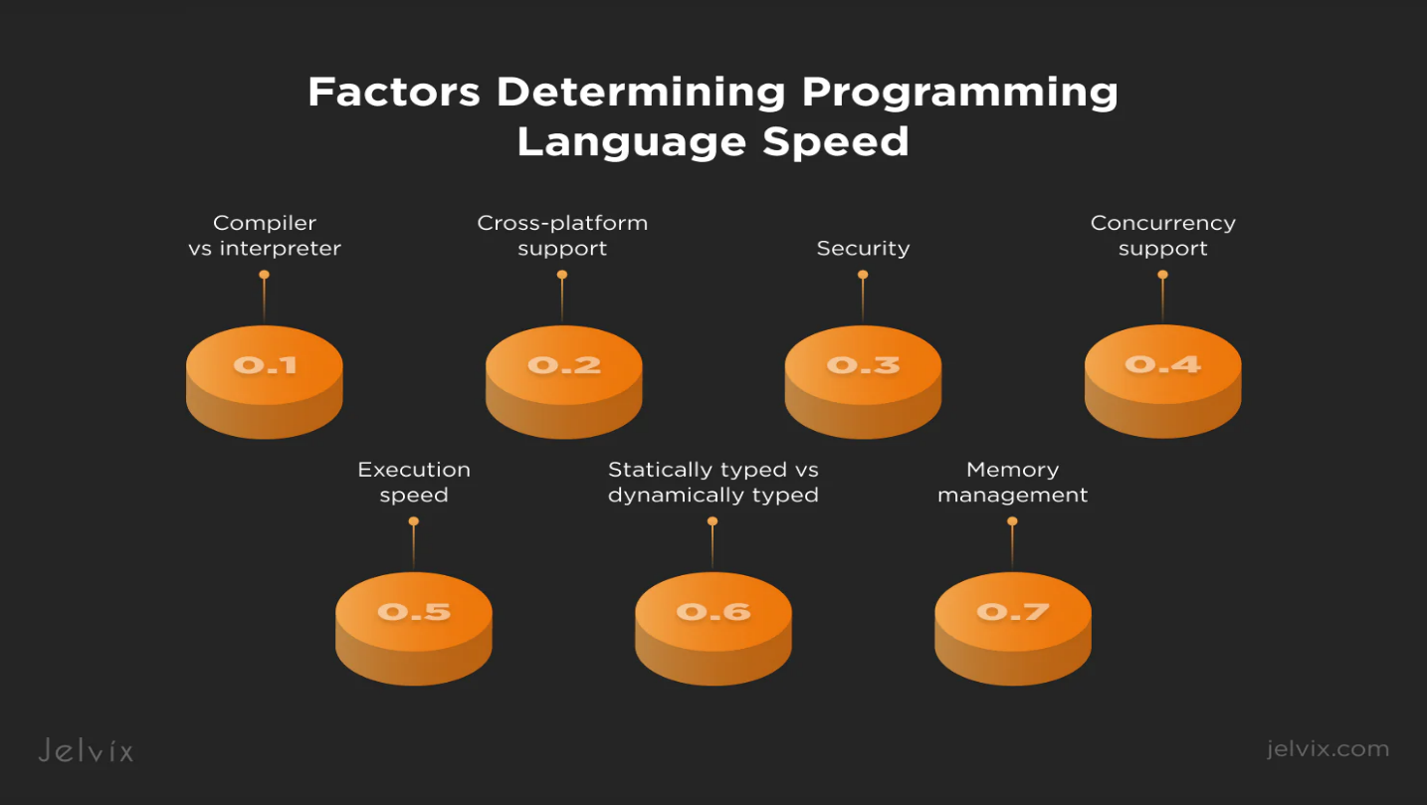
Appendix B
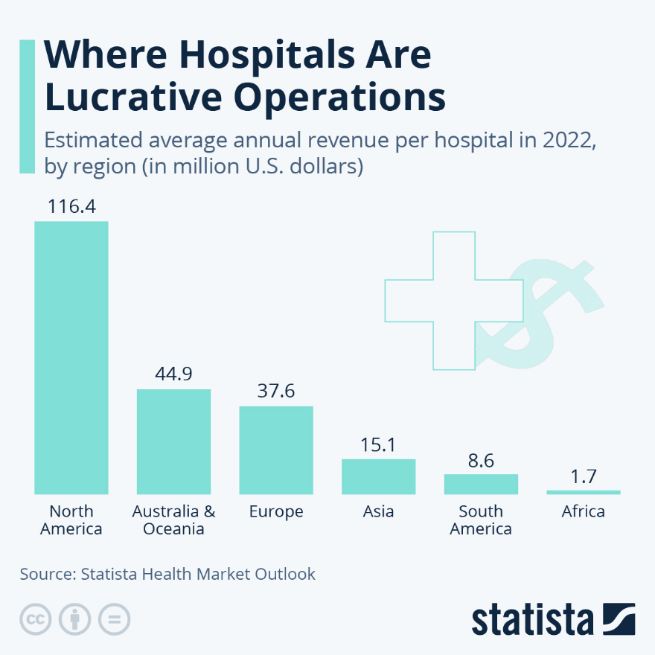

Flow chart or pseudo-code.
